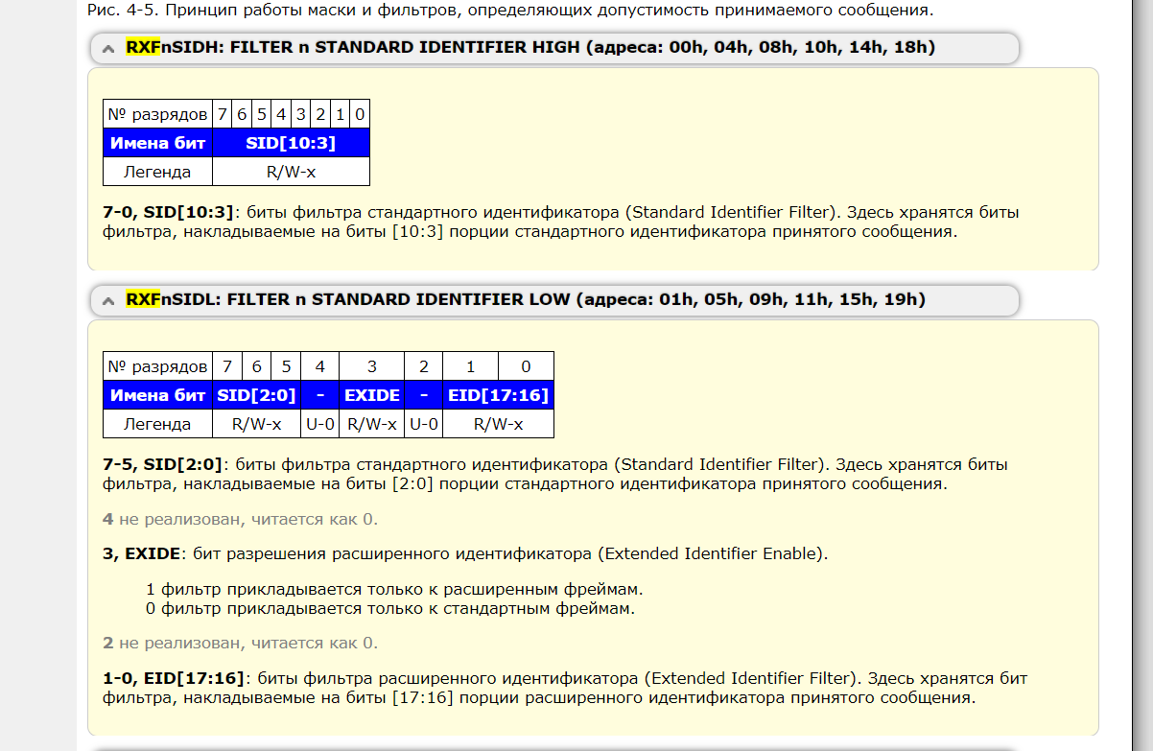

Type 0

0x31C (796) > 0011 0001 1100

SIDH = 0x63 > 0110 0011

SIDL = 0x80 > 1000 0000

Type 1

0x320 (800) > 0011 0010 0000

SIDH = 0x64 > 0110 0011

SIDL = 0x00 > 1000 0000

* **Получить ID из SIDH и SIDL**

*char* SIDH = 0x63;  
*char* SIDL = 0x80;  
*int* id = ((uint8_t) SIDH << 3) | ((uint8_t) SIDL >> 5);  
printf("%d\r\n", id);

* **Получить SIDH и SIDL из ID**

*int* id = 800;  
*char* SIDL;  
*char* SIDH;  
id = id << 5;  
SIDL = 0xFF & (*char*) id;  
id = id >> 8;  
SIDH = 0xFF & (*char*) id;  
printf("%02X %02X\r\n", SIDH, SIDL);